Supplementary Materials

Integrating Prospective and Retrospective Cues to the Sense of Agency: A Multi-Study Investigation
Nura Sidarus, Matti Vuorre, Patrick Haggard

Instructions
To clarify the differences in instructions between Group 1 and 2 studies, we include below a summary and example of the instructions about agency ratings given in each group of studies. These were obtained from the lead experimenters (Group 1: Nura Sidarus; Group 2: Valerian Chambon).

Group 1
The instructions focused uniquely on outcome identity – the colour of the circle.
“You should pay careful attention to the relationship between your action and the colour that appears.
At the end of each trial, we will ask you to rate how much control you felt over the coloured circle. For this, you should press a key from 1 to 9 when the scale appears on the screen, where 1 = “No Control” and 9 = “Total Control”. You should try to use the whole scale, to show differences in how you feel across the trials.
Bear in mind that the relation between actions and colours may change between blocks.”

Group 2
The instructions focused primarily on the action-outcome interval. The experimenter also mentioned verbally to participants that they should pay attention to the colour of the circle. However, this was not particularly emphasised, and they were not instructed that the relation between actions and colours changed between blocks.
“We will ask you to make button presses (left or right index finger) to arrows you see presented on the screen. After you make your button press, a coloured circle will appear. On each trial, we will ask you how much you thought you were in control of when the coloured circle appeared (ie., to what extent your response caused the coloured circle to appear). You will make this judgement using the 8 button-box, ranging from “no control” (1) to “complete control” (8). Try to use the whole scale when making your judgements.”

Multilevel linear regression.
In addition to the logistic regression model reported in the main article, we also tested a three-level multilevel linear regression model. Here, the effects of trial was entered as a linear and quadratic predictor (computed using orthogonal polynomials, range of linear trial predictor = [-0.28, 0.28]). The effects of trial (linear and quadratic), congruency, AOI, congruency by trial (linear) interaction, and congruency by AOI interaction were treated as varying between subjects and experiments, and as fixed effects. Additionally, we interacted these effects with a group indicator variable at the fixed-effect level. As shown in Table S1 and Figure S1, the findings replicate those observed using logistic regression.
Table S1. Multilevel model of agency ratings.
Effects of primary interest are highlighted in bold.
 |  |  |  | 95% CI
Average Effect | Estimate (SE) | t | p | Lower | Upper
Intercept | 5.22 (0.25) | 20.80 | < 0.001 | 4.73 | 5.72
Trial | 4.21 (0.57) | 7.32 | 0.001 | 3.08 | 5.34
Trial (quadratic) | -1.18 (0.31) | -3.82 | 0.014 | -1.79 | -0.58
Congruency | 0.28 (0.05) | 5.25 | 0.008 | 0.18 | 0.39
AOI | 0.01 (0.03) | 0.43 | 0.665 | -0.04 | 0.06
Group | -0.75 (0.39) | -1.90 | 0.110 | -1.52 | 0.02
Trial x Congruency | 0.65 (0.19) | 3.42 | 0.001 | 0.28 | 1.02
Congruency x Group | 0.03 (0.10) | 0.34 | 0.746 | -0.16 | 0.23
AOI x Group | -0.28 (0.04) | -6.60 | < 0.001 | -0.37 | -0.20
Congruency x AOI | 0.02 (0.02) | 1.05 | 0.293 | -0.01 | 0.05
Trial x Group | -3.76 (0.91) | -4.14 | 0.008 | -5.55 | -1.98
Trial (quad.) x Group | 0.90 (0.50) | 1.79 | 0.125 | -0.08 | 1.88
Trial x Congruency x Group | -0.92 (0.39) | -2.36 | 0.019 | -1.69 | -0.16
Congruency x AOI x Group | 0.02 (0.03) | 0.67 | 0.500 | -0.04 | 0.08
Note: p-values were computed using the Satterthwaite approximation (Kuznetsova, Brockhoff, & Christensen, 2015). Confidence intervals were obtained using the Wald method (Bates et al., 2014). ‘x’ denotes interaction terms.

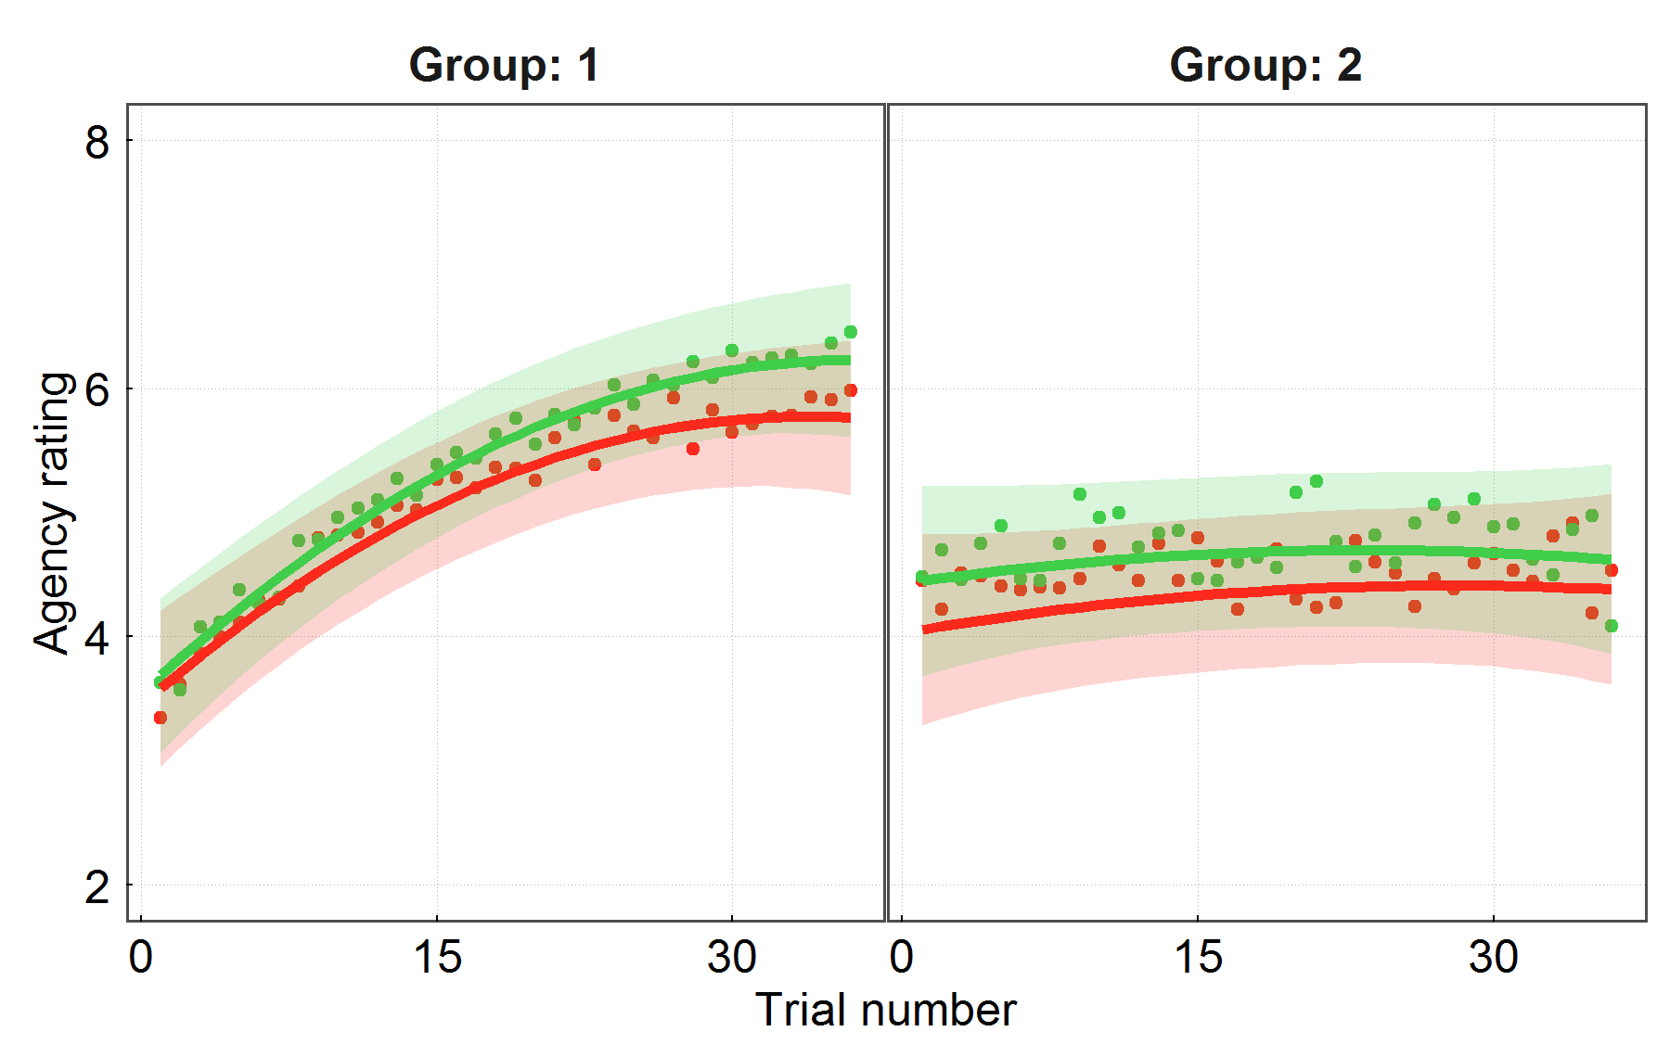
Figure S1. Multilevel linear regression model of agency ratings.
Predicted average agency ratings for each Group as a function of trial number (with 95% confidence intervals as shades around regression lines; dots are means from raw data across experiments within each Group). Green = congruent, red = incongruent. Regression lines and CIs were obtained from 100000 simulations from the posterior distribution of plausible parameter values under uniform priors (Gelman & Su, 2015).

Independent models.
In addition to fitting a three-level multilevel regression model to all experiments simultaneously, we also fit separate two-level regression models to each experiment’s data. We used the same coding for the variables for these models as the one presented in the main article, but included all trials for each experiment. The by-subject varying effects (all average effects were allowed to vary within subjects) were modelled as uncorrelated because specifying correlated random effects led to non-convergence.
Tables 1-7 present the results of these models, for each experiment. Effects of primary interest are highlighted in bold.

Group 1
The results from the independent models fitted to experiments from Group 1 led to identical conclusions as the model presented in the main article. Importantly, Congruency and Trial number exerted a positive influence on agency ratings across experiments, but action-outcome interval (AOI) did not. Congruency and Trial number interacted in all experiments, except in Experiment 2.
The lack of a Congruency by Trial interaction in Experiment 2 (see Table S2) may result from two important differences in experimental design relative to other Group 1 experiments: there were 3 congruency conditions – congruent, neutral, and incongruent; and 3 AOIs. Notably, even though there were 3 AOIs, as in the experiments of Group 2, this factor did not influence agency ratings. While the neutral condition was excluded from the present analyses, it may have impacted on the learning of action-outcome contingencies, as well as on potential interactions between congruency and outcome identity. The significant effect of trial number shows that outcome identity was still driving agency ratings, but the slope of the increase in agency ratings across trials was reduced relative to other Group 1 experiments (see Figure 3 in main article). Therefore, this reduced the potential for dynamic changes in the effects of selection fluency on the sense of agency.
Table S2. Multilevel logistic regression model of agency ratings for Experiment 1.
Average Effect | Estimate (SE) | z | p
Intercept | 0.046 (0.097) | 0.48 | .63
Trial | 0.028 (0.0045) | 6.12 | <.0001
Congruency | 0.054 (0.056) | 0.97 | .33
AOI | 0.0012 (0.0089) | 0.14 | .89
Trial x Congruency | 0.008 (0.0032) | 2.53 | .01
Trial x AOI | 0.0019 (0.0013) | 1.47 | .14
Congruency x AOI | 0.036 (0.025) | 1.43 | .15
Trial x Congruency x AOI | -0.0027 (0.0019) | -1.45 | .15

Table S3. Multilevel logistic regression model of agency ratings for Experiment 2.
Average Effect | Estimate (SE) | z | p
Intercept | 0.11 (0.26) | 0.41 | .68
Trial | 0.015 (0.0074) | 2.07 | .04
Congruency | 0.2 (0.044) | 4.54 | <.0001
AOI | 0.0054 (0.012) | 0.46 | .64
Trial x Congruency | 0.0013 (0.0047) | 0.27 | .79
Trial x AOI | -0.005 (0.0014) | -3.49 | .0005
Congruency x AOI | 0.042 (0.031) | 1.37 | .17
Trial x Congruency x AOI | -0.001 (0.0023) | -0.44 | .66

Table S4. Multilevel logistic regression model of agency ratings for Experiment 3.
Average Effect | Estimate (SE) | z | p
Intercept | 0.54 (0.14) | 3.79 | .0001
Trial | 0.033 (0.0048) | 6.91 | <.0001
Congruency | 0.19 (0.064) | 2.96 | .003
AOI | 0.015 (0.0095) | 1.54 | .12
Trial x Congruency | 0.0073 (0.003) | 2.45 | .01
Trial x AOI | -5.3e-05 (0.0011) | -0.05 | .96
Congruency x AOI | -0.025 (0.027) | -0.95 | .34
Trial x Congruency x AOI | -0.0012 (0.0024) | -0.5 | .62

Table S5. Multilevel logistic regression model of agency ratings for Experiment 4.
Average Effect | Estimate (SE) | z | p
Intercept | 0.82 (0.2) | 4.12 | <.0001
Trial | 0.064 (0.01) | 6.15 | <.0001
Congruency | 0.2 (0.066) | 3.01 | .003
AOI | 0.0035 (0.0053) | 0.67 | .50
Trial x Congruency | 0.0082 (0.0027) | 3.04 | .002
Trial x AOI | 0.00091 (0.00064) | 1.43 | .15
Congruency x AOI | 0.011 (0.0094) | 1.16 | .25
Trial x Congruency x AOI | -0.0016 (0.001) | -1.6 | .11

Group 2
The independent model fits presented here further corroborate the results obtained from the three-level multilevel model presented in the main article. Congruency and AOI both exerted noticeable effects on SoA. Importantly, Trial number and Trial by Congruency effects were not reliable in the studies in Group 2. There was a small effect of Trial number in Experiment 6 (Table S7). The slight increase in agency ratings over trials found for this experiment may be due to the fact that it had the longest block length of these experiments (see Table 1 in main article). This suggests that focusing on AOI may slow down the learning of action-outcome contingencies, thus requiring longer before outcome identity influences SoA.
Table S6. Multilevel logistic regression model of agency ratings for Experiment 5.
Average Effect | Estimate (SE) | z | p
Intercept | 0.15 (0.082) | 1.83 | .07
Trial | 0.0039 (0.0026) | 1.47 | .14
Congruency | 0.12 (0.034) | 3.68 | .0002
AOI | -0.13 (0.046) | -2.75 | .006
Trial x Congruency | -0.0035 (0.0045) | -0.78 | .44
Trial x AOI | -0.00067 (0.00089) | -0.76 | .45
Congruency x AOI | 0.0029 (0.018) | 0.16 | .87
Trial x Congruency x AOI | 0.0026 (0.0017) | 1.57 | .12

Table S7. Multilevel logistic regression model of agency ratings for Experiment 6.
Average Effect | Estimate (SE) | z | p
Intercept | 0.48 (0.072) | 6.61 | <.0001
Trial | 0.0038 (0.0025) | 1.56 | .12
Congruency | 0.25 (0.069) | 3.68 | .0002
AOI | -0.2 (0.053) | -3.67 | .0002
Trial x Congruency | 0.00016 (0.0045) | 0.04 | .97
Trial x AOI | 0.00018 (0.0013) | 0.14 | .89
Congruency x AOI | 0.013 (0.023) | 0.54 | .59
Trial x Congruency x AOI | 0.0018 (0.0018) | 0.97 | .33

Table S8. Multilevel logistic regression model of agency ratings for Experiment 7.
Average Effect | Estimate (SE) | z | p
Intercept | 0.21 (0.22) | 0.95 | .34
Trial | 0.0018 (0.0054) | 0.34 | .73
Congruency | 0.18 (0.062) | 2.88 | .004
AOI | -0.18 (0.082) | -2.19 | .03
Trial x Congruency | -0.0018 (0.008) | -0.22 | .83
Trial x AOI | -0.0011 (0.0022) | -0.49 | .63
Congruency x AOI | 0.051 (0.034) | 1.51 | .13
Trial x Congruency x AOI | -0.0091 (0.0042) | -2.17 | .03

